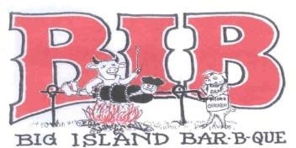
SCA Judging Application Big Island Barbeque
August 20, 2022, City Arena 701 Lake Chapeau Drive, Albert Lea, Minnesota 56007
SIGN UP ONLINE AT Steakcookoffs.com

Thank you for volunteering to judge at the Big Island Barbeque! You will be contacted and updated by E-Mail as to your judging position. Please fill out a separate application for each person who wishes to judge. When you signed up for this contest, you agreed to be part of the judging process. The judging process includes Judging, working the Turn-In- Table/Number Changing area and helping at the Leftover area.
Name: Address:
City State Zip: Home or Cell Phone
Email:

Be assured we / I will NOT share your information with other groups, but I will / could contact you with their information. Mail or E-mail this completed application to: Dick Dahlen 1320 Briarwood Drive, Albert Lea, MN 56007. If something comes up and you can’t judge, please notify us immediately.
Sincerely,
Dick Dahlen ddahlen@charter.net

SCA judges Friday August 20, 2022, sign up online www.steakcookoffs.com

WAIVER OF LIABILITY: (Must be signed to judge) In consideration for the BIB Committee accepting this application, I, the undersigned, intending to be legally bound, hereby, for myself, my heirs, executors, and administrators, waive and release any and all rights and claims for damages I may have against the Big Island Rendezvous and Festival, Inc. and the City of Albert Lea and the committee, their agents, successors, and assigns for any and all injuries suffered by me in this event.
Further, I hereby grant full permission to Big Island Rendezvous and Festival, Inc. or their authorized agents to use any photographs, videotapes, recordings or any other record including digital and internet on this event for any legitimate pose. I agree to abide by all contest rules set out by the Big Island Barbeque, the KCBS and SCA.

Signature Date

